WHATNEXT VISION MOTORS
Shaping the Future of Mobility with Innovation and Excellence
COLLEGE NAME:
UNIVERSITY COLLEGE OF ENGINEERING - THIRUKKUVALAI
COLLEGE CODE:
8222
TEAM MEMBERS:
DARANI A (TEAM LEAD) - 822223104014
VARSHA S -822223104004
DHANALAKSHMI K - 822223104035
SOWMIYA M - 822223104018
EMAIL ID:
DARANI A -daraniayyappan0@gmail.com
VARSHA S -meenamarimeenamari@gmail.com
DHANALAKSHMI K -dhanam2006.09@gmail.com
SOWMIYA M - sowmiyam060@gmail.com
NM ID:
DARANI - 674390E15F5DAEB8F46488FAA8288C86
VARSHA - ACAB310271C41138FDA466962009468F
DHANALAKSHMI - E7858B39106751DB0484ADBDB40C177B
SOWMIYA - 29629cb624fc8f3b31846373af87133d
TEAM LEAD PROFILE LINK:
https://www.salesforce.com/trailblazer/un9l8w6akzv6r03veV

s.no | Task Name | Assign To | Date Completion
 | User Scenario | Darani A | 02.10.2026
 | Developer Account Creation | Darani A | 02.10.2026
 | Verify Account | Darani A | 02.10.2026
 | Object Creation-Vehicle | Darani A | 02.10.2026
 | Create Dealer Object | Varsha S | 02.10.2026
 | More Object Creation | Varsha S | 02.10.2026
 | Object Tab Creation | Varsha S | 02.10.2026
 | More Tabs Creation | Varsha S | 02.10.2026
 | Create Lightning App | Dhanalakshmi K | 02.10.2026
 | Object Field Creation | Dhanalakshmi K | 02.10.2026
 | Object Field Creation-2 | Dhanalakshmi K | 02.10.2026
 | Relationship Field Creation | Dhanalakshmi K | 02.10.2026
 | More Fields Creation | Sowmiya M | 02.10.2026
 | Flow Creation | Sowmiya M | 02.10.2026
 | Record-Trigger Flow Creation | Sowmiya M | 02.10.2026
 | Create Apex and Trigger Batch Jobs | Sowmiya M | 02.10.2026

ABSTRACT
WhatNext Vision Motors is a Salesforce CRM-based vehicle ordering and dealership management solution designed to improve vehicle sales operations. The project brings vehicle ordering, stock validation, dealer assignment, test-drive reminders, order status updates, and reporting into a centralized platform.
The system uses Salesforce Lightning, custom objects, Flows, Apex Triggers, Batch Apex, Scheduled Apex, Reports, and Dashboards. It manages vehicle, dealer, customer, order, test drive, and service request information.
The project automates important activities such as assigning orders to dealers, checking vehicle stock, updating order status, and sending test-drive reminders. This reduces manual work, prevents order errors, and improves operational efficiency and customer satisfaction.
The project demonstrates how Salesforce CRM can be used to integrate business requirements with automation and application development. The system was tested for vehicle creation, dealer assignment, stock validation, order processing, reminders, and dashboard reporting.

TABLE OF CONTENTS
- Introduction
- Problem Statement
- About the Project
- Milestone 1 – Salesforce Account
- Milestone 2 – Data Management – Objects
- Milestone 3 – Data Management – Tabs
- Milestone 4 – App Manager
- Milestone 5 – Data Management – Fields
- Milestone 6 – Automation
10.Milestone 7 – Apex and Batch Class
11.Conclusion

INTRODUCTION
- WhatNext Vision Motors is a Salesforce CRM-based project designed to improve vehicle ordering and dealership management.
- The project provides a centralized platform to manage vehicles, customers, dealers, orders, test drives, and service requests.
- It automates important activities such as stock validation, dealer assignment, order processing, and test-drive reminders.
- Salesforce Flows, Apex Triggers, Batch Apex, Scheduled Apex, Reports, and Dashboards are used to support the system.
- The project helps reduce manual work, improve data accuracy, and provide better visibility of vehicle orders and dealership operations.
- Overall, the system aims to improve operational efficiency and customer experience through Salesforce automation.

PROBLEM STATEMENT
- Vehicle orders are managed manually, making the process time-consuming and difficult to track.
- Vehicle stock availability is not clearly maintained, causing uncertainty during order processing.
- Customer, vehicle, dealer, and order information are handled through separate processes.
- Customers may experience delays in receiving order status and vehicle availability updates.
- Manual processes can lead to errors and delays in managing vehicle orders.
- A centralized Salesforce-based system is required to automate order management, stock validation, dealer assignment, and customer updates.

ABOUT THE PROJECT
WhatNext Vision Motors is a Salesforce CRM-based vehicle ordering and dealership management system. It provides a centralized platform to manage vehicle, dealer, customer, order, test drive, and service request information.
Key Features
- Vehicle Management – Maintains vehicle details, price, stock quantity, dealer, and status.
- Dealer Management – Stores dealer details and manages dealer-related information.
- Customer Management – Maintains customer details and vehicle preferences.
- Vehicle Order Management – Handles customer vehicle orders and order status.
- Stock Validation – Checks vehicle availability before processing an order.
- Automatic Dealer Assignment – Assigns orders to the appropriate dealer based on customer location.
- Test Drive Management – Manages test-drive details and schedules reminders.
- Reports and Dashboards – Provides useful information about orders, vehicles, and overall operations.

MILESTONE 1 – SALESFORCE ACCOUNT
- Created a Salesforce Developer Account for the project.
- Entered the required account details during the registration process.
- Activated the Salesforce account through the confirmation email.
- Logged in to the Salesforce Developer Environment.
- Prepared the Salesforce environment for further project development and configuration.

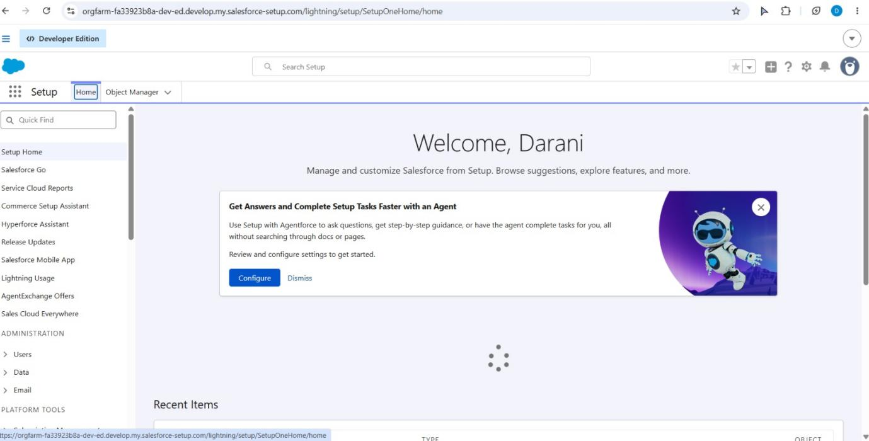

MILESTONE 2 – DATA MANAGEMENT – OBJECTS
- Created the required Custom Objects in Salesforce for managing project data.
- Created the following objects:
  - Vehicle
  - Vehicle Dealer
  - Vehicle Customer
  - Vehicle Order
  - Vehicle Test Drive
  - Vehicle Service Request
- Established the required relationships between the objects.
- These objects provide a structured way to store and manage vehicle, dealer, customer, order, test-drive, and service information.
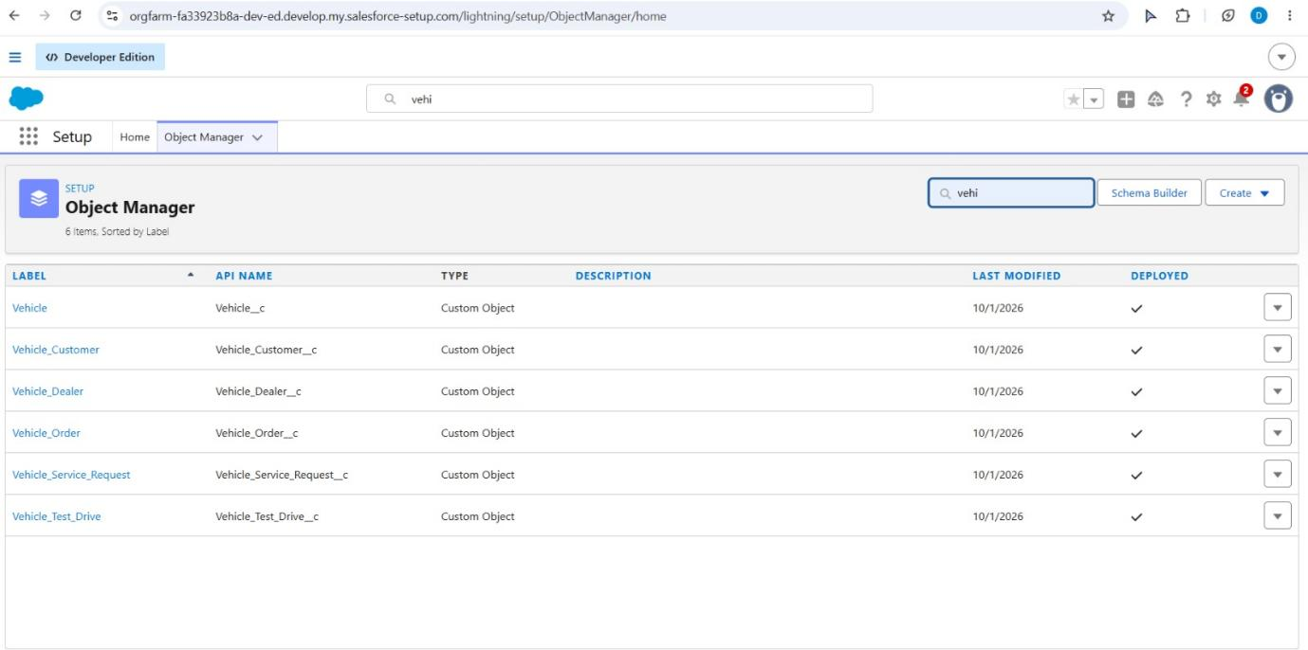

MILESTONE 3 – DATA MANAGEMENT – TABS
- Created Custom Tabs for the objects created in Milestone 2.
- Created tabs for:
  - Vehicle
  - Vehicle Dealer
  - Vehicle Customer
  - Vehicle Order
  - Vehicle Test Drive
  - Vehicle Service Request
- Configured the tabs to make the objects easily accessible in the Salesforce application.
- These tabs provide simple navigation and help users manage project data efficiently.
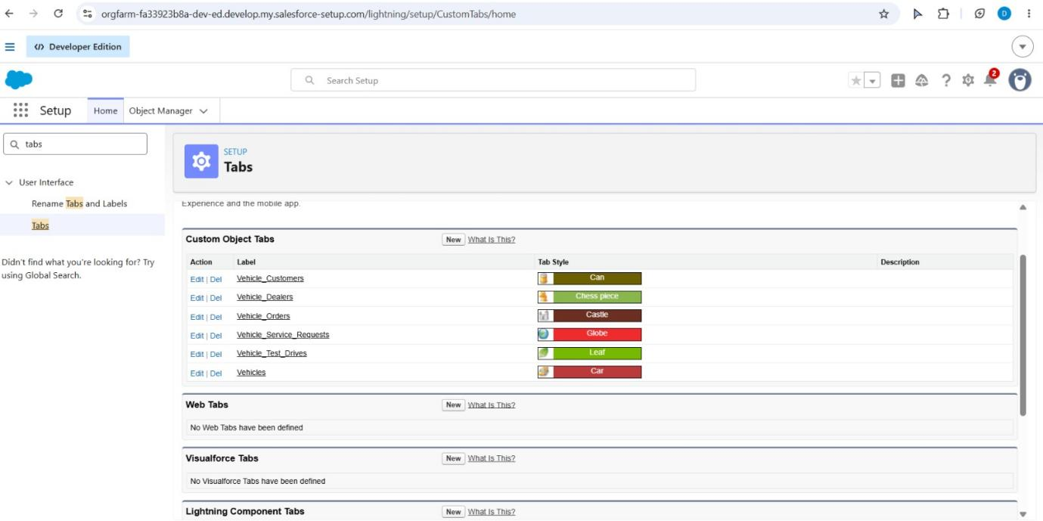

MILESTONE 4 – AUTOMATION AND APEX DEVELOPMENT

• Created Record-Triggered Flows to automate vehicle order processes.
• Configured automatic dealer assignment based on customer location.
• Created a Test Drive Reminder Flow to send reminders before scheduled test drives.
• Developed Apex Trigger to validate vehicle stock before order processing.
• Updated vehicle stock automatically when an order is confirmed.
• These automations reduce manual work and improve order processing efficiency. 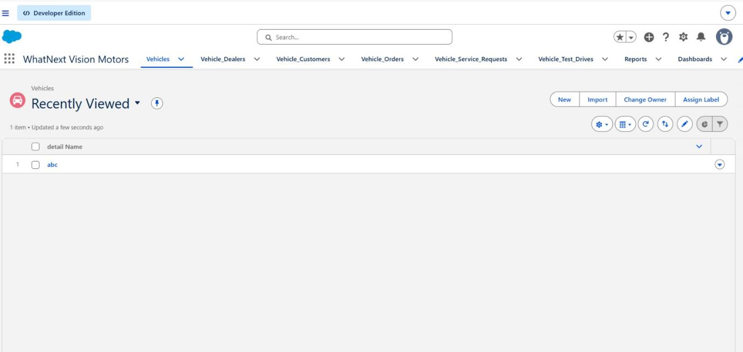

MILESTONE 5 – BATCH AND SCHEDULED PROCESSING

• Created Batch Apex to process pending vehicle orders.
• Checked the available vehicle stock for pending orders.
• Updated eligible pending orders to Confirmed when stock became available.
• Reduced the vehicle stock by one for each confirmed order.
• Created Scheduled Apex to run the batch process automatically at a scheduled time.
• This automation reduces manual work and keeps order and stock information updated. 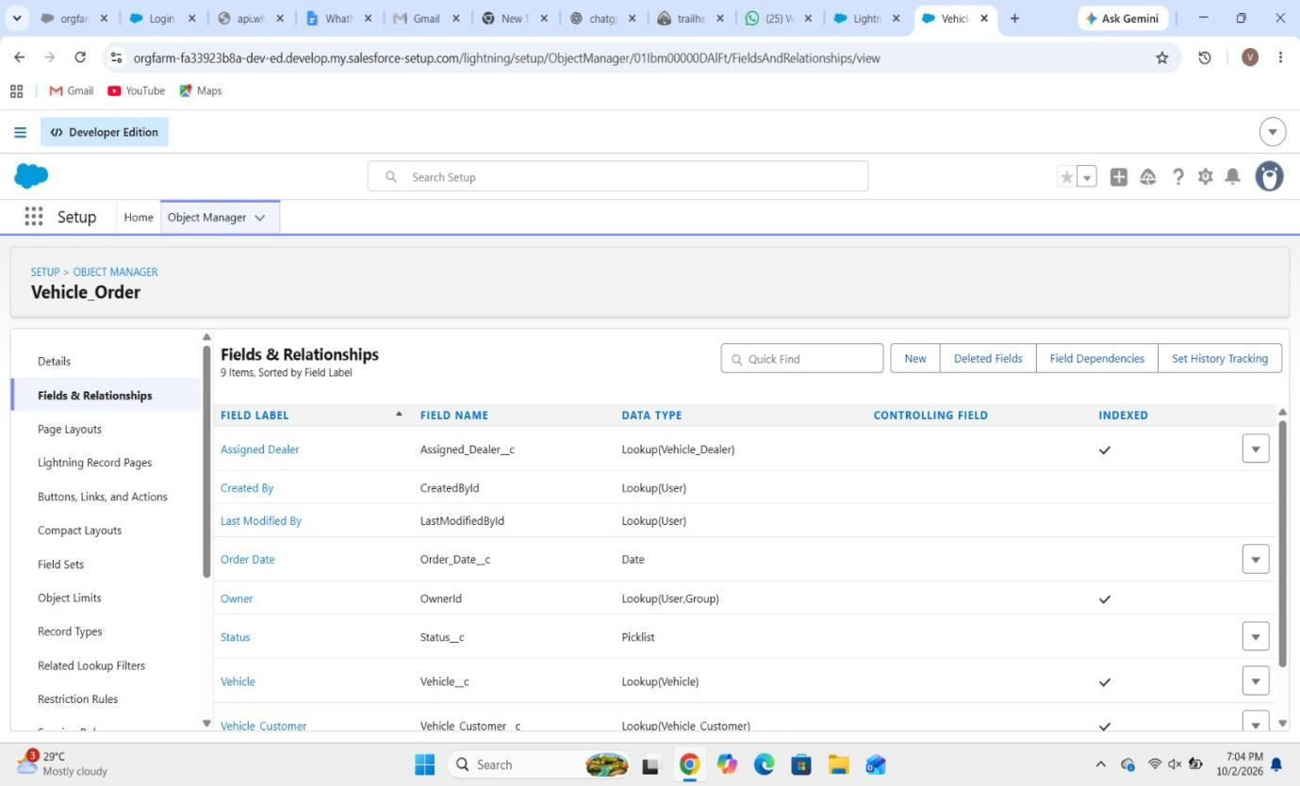

MILESTONE 6 – REPORTS AND DASHBOARDS
• Created Reports to monitor vehicle orders and dealership activities.
• Created reports for:
o Order Status
o Dealer Performance
o Sales Metrics
• Created Dashboards to display important project information visually.
• Configured reports and dashboards for easy operational monitoring.
• These reports and dashboards help users track orders, dealers and sales information efficiently. 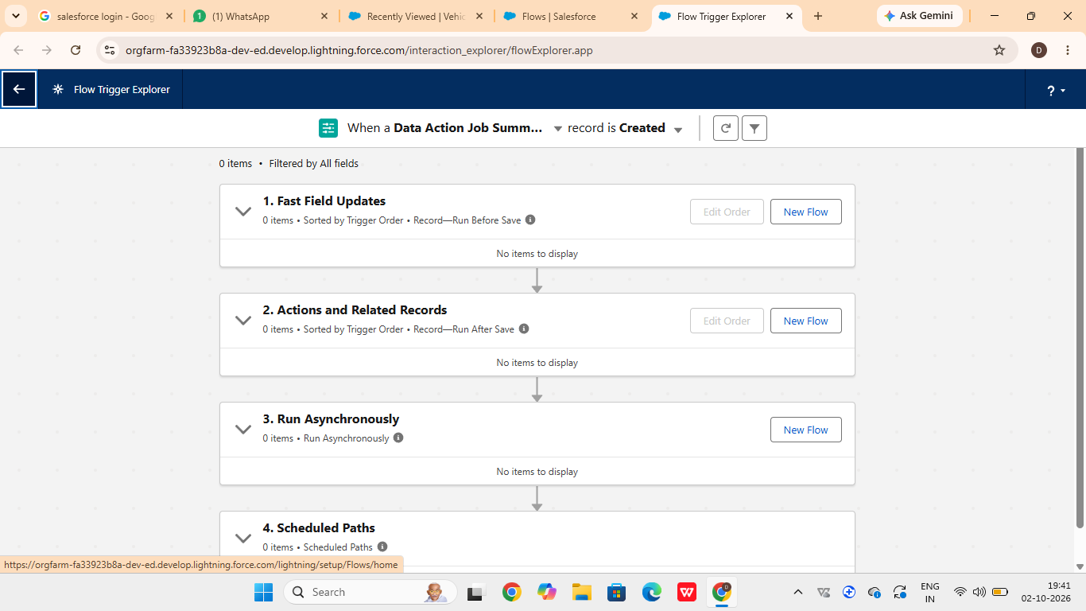

MILESTONE 7 – TESTING AND VALIDATION

• Tested the vehicle creation process with the required details.
• Tested dealer assignment based on customer location.
• Tested stock validation to prevent out-of-stock orders.
• Tested order status updates and stock reduction for confirmed orders.
• Tested Batch Apex processing for pending orders when stock became available.
• Tested scheduled reminders and dashboard analytics.
• Verified that the implemented features work correctly and efficiently. 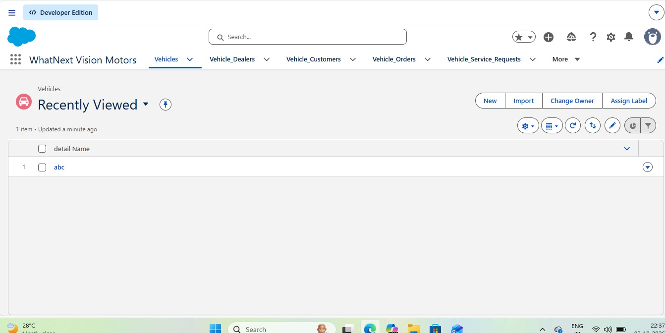

CONCLUSION

The WhatNext Vision Motors project successfully demonstrates a Salesforce CRM-based vehicle ordering and dealership management system. The project integrates vehicle, dealer, customer, order, test drive and service request management in a centralized platform.

Salesforce Flows, Apex Triggers, Batch Apex and Scheduled Apex are used to automate important business processes such as dealer assignment, stock validation, order processing and test-drive reminders. Reports and Dashboards provide better visibility of orders, dealers and sales activities.

Overall, the project helps reduce manual work, improve order accuracy, manage vehicle stock efficiently and provide a structured solution for vehicle dealership operations. The system can be further enhanced with mobile ordering, GPS integration, SMS notifications and AI-based demand forecasting.

THANK YOU !!!

